MICROSOFT INTUNE IN SECURING DEVICES: BALANCING SECURITY FEATURES AND USER EXPERIENCE IN ENTERPRISE ENVIRONMENTS

1st Syed Saifulla H 2nd DR.Srabana
Dept. of SOCSE Dept. of SOCSE
Presidency University Professor
Bangalore, India. Presidency University
Saifulla.saif@icloud.com Bangalore, India.

Abstract— The widespread migration of organizational infrastructure to cloud environments is primarily driven by the pursuit of enhanced productivity and reduced operational expenditure. However, this transition introduces significant challenges in enterprise mobility management. Managing a diverse fleet of devices within the complex Microsoft ecosystem remains a critical hurdle for many organizations. Microsoft Intune, a cloud-based service, was developed to address these challenges by providing a unified platform for device management and security. This paper presents a systematic evaluation of Microsoft Intune's effectiveness in bolstering device security within enterprise settings. Employing a mixed-methods approach that combines technical testing in a laboratory environment with user surveys across multiple organizations, this research assesses the impact of core security features—such as device encryption, multi-factor authentication, and app protection policies—on both security posture and user experience. The findings offer a statistical analysis of the trade-offs between robust security and usability, providing organizations with an evidence-based framework to configure Intune optimally, thereby minimizing security incidents without compromising end-user productivity.

Keywords: Microsoft Intune, Mobile Device Management (MDM), Enterprise Mobility Management (EMM), Endpoint Security, User Experience, Cloud Security

I. INTRODUCTION
The security of end-user devices represents a critically underexplored domain within cloud security. While organizations are adept at adopting new technologies, the success of security implementations is profoundly influenced by their impact on the end-user. A fundamental dichotomy exists: stringent security measures, while effective at protecting corporate assets, can inadvertently create friction that degrades user experience and hampers productivity. For instance, requiring a BitLocker recovery key, biometric authentication, and a complex password for every sign-in presents a formidable security barrier but may lead to user frustration, workarounds, and reduced efficiency. This tension between security rigor and usability is a central challenge in modern device management.
The rapid proliferation of cloud services and mobile devices in enterprise environments has compounded this challenge, forcing IT and security teams to navigate a complex landscape. They must enforce robust security controls to protect against evolving threats while simultaneously fostering a seamless and productive user experience. Microsoft Intune, as a cloud-based Enterprise Mobility Management (EMM) solution, offers a comprehensive suite of tools designed to meet these conflicting demands. However, the real-world effectiveness of these tools and their tangible impact on the user requires systematic and empirical evaluation.

II. Literature Review

The challenge of securing mobile endpoints in enterprises is not new. Over a decade ago, De los Reyes et al. [1] proposed a security architecture leveraging network-based security and cloud computing for the mobile enterprise. Subsequent research by Song and Yang [2] focused on the device level, utilizing the Android Open Source Project (AOSP) and SELinux to build a mobile device management (MDM) system capable of tracking, permission control, and real-time monitoring for both corporate and BYOD devices.

The role of broader enterprise systems in enabling secure mobility was highlighted by Baltazar et al. [3], who demonstrated through a case study on a carsharing platform how Enterprise Information Systems (EIS) can drive sustainable mobility, also noting the emerging significance of AI and machine learning for security. Building on this, Hasan et al. [4] proposed a framework for designing secure mobile enterprise applications, incorporating a meta-model and guidance for addressing threats, though its effectiveness against novel, zero-day attacks remains a challenge.

The management of BYOD devices has been a persistent theme. Batool [5] conducted a comparative analysis of major MDM solutions like AirWatch, IBM MaaS360, and Kaspersky, evaluating them against a checklist of security requirements. However, this and similar studies often stop at feature comparison, lacking an assessment of their practical security effectiveness. Strategic considerations for enterprise mobility were addressed by Yucel [6], who developed a model to link factors like user adoption and economic utility with overall return on investment.

A parallel and critical area is Mobile Application Management (MAM). The challenges of pushing and managing applications through a centralized console were explored by Yamin and Katt [7] and others [8, 9]. Suduca and Bizoa [10] provided a practical example by using Microsoft Intune to deploy the Zoom videoconferencing app, demonstrating significant time savings compared to manual methods.

A consistent limitation across the reviewed literature is a predominant focus on feature comparison rather than empirical measurement of effectiveness. This paper addresses this gap by moving beyond a feature checklist. It presents a real-world test scenario and provides a statistical analysis of the trade-offs between security implementations and user experience, offering actionable insights for Security Operations and IT teams.

III. Background
Microsoft Intune is Microsoft's cloud-based service that acts as an enterprise mobility management (EMM) and MDM solution. Microsoft Intune supports a diverse range of operating systems: Windows, macOS, Android, Linux, and iOS devices. There are several ways to accomplish the onboarding process for devices to Microsoft Intune: group-based, Autopilot, Apple Business Manager for iOS devices, and Android Enterprise for Android devices. Additionally, the user onboarding process can be performed automatically during the first sign in with Windows credentials, or via the Company Portal application from the store for mobile devices. After the onboarding process, users will receive a set of policies that were configured in Microsoft's security portal and can receive new policy enforcements during subsequent policy update cycles. The high-level architecture of Microsoft Intune is given in the following figure.

- System Architectural Diagram

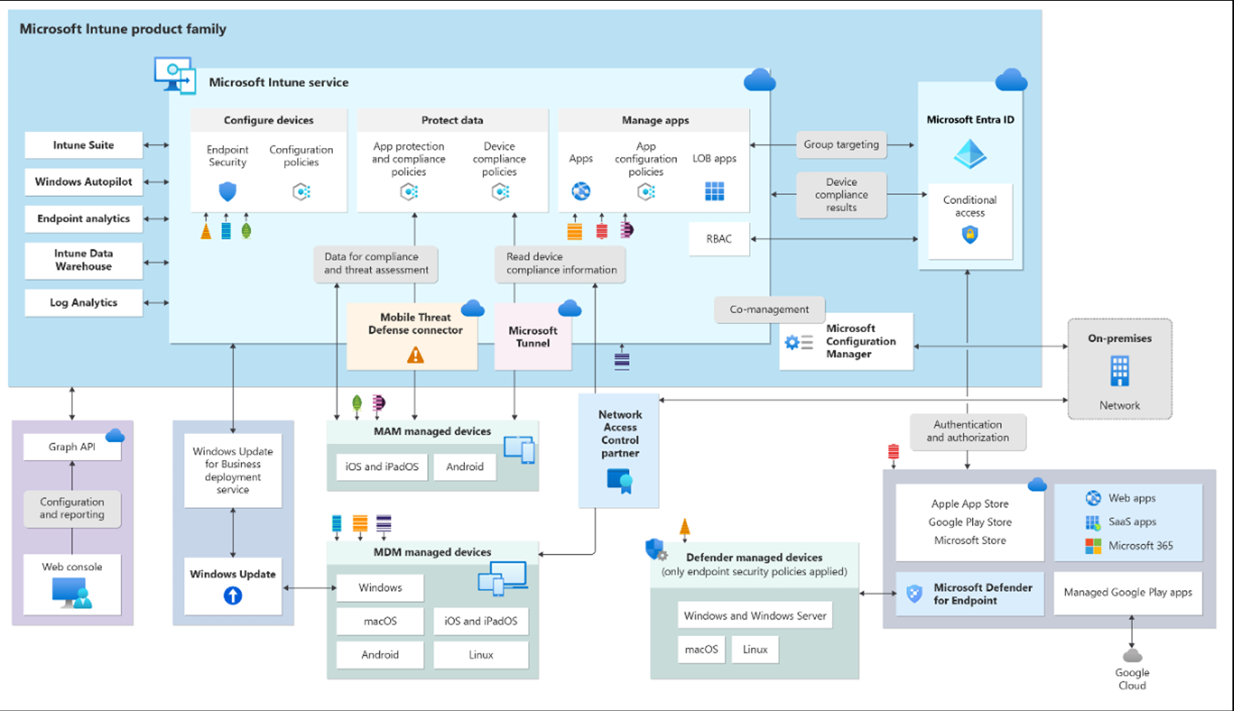
High-level Microsoft Intune architecture

As shown in Fig. 1, the architecture consists of several components such as: Microsoft Intune service, Graph API, Windows Update for Business deployment service, MAM managed devices, Network Access Control partner, and Microsoft Configuration Manager for on-premises deployment. Moreover, the figure depicts Intune's integration with Microsoft Defender for Endpoint, a comprehensive security solution that functions as both an antivirus and endpoint detection and response suite. This integration underscores the security measures that can be implemented via Microsoft Defender for Endpoint within the Microsoft ecosystem.
IV. PROPOSED METHODOLOGY
To evaluate the effectiveness of Microsoft Intune, a structured methodological approach was developed. This methodology encompasses several key phases designed to provide comprehensive insights into both security effectiveness and user experience impact.
- Evaluation Criteria Definition

The first step involves defining specific criteria for evaluation:
- Device compliance rates: Percentage of devices meeting security requirements
- Malware detection and prevention: Effectiveness of Microsoft Defender integration
- Remote wipe effectiveness: Time and success rate for device wiping
- Time to deploy security patches: Efficiency of update distribution
- Time to update policies: Responsiveness of policy enforcement
- App protection policy enforcement: Effectiveness of application-level controls

- Data Gathering Framework

This step underscores the necessity of gathering important data for preventing attacks. For instance, an endpoint's IP address and agent status can be considered as data to understand the endpoint's current security status. Data was collected from:
- Laboratory test environment with isolated network
- Production environments across multiple organization types
- User surveys measuring experience impact
- System logs and compliance reports

- Comparative Analysis Framework

Microsoft Intune has many mechanisms in terms of configuration, policies, and integrations. Considering this, best practices will be used to build a secure ecosystem across the organization. The analysis compares:
- Different security feature implementations
- Various policy configurations
- Multiple organization types and requirements
- User experience across different security levels

- Technical Evaluation Parameters

From a technical perspective, the solution should be:
- Scalable: Ability to handle growing number of devices
- Adaptable: Flexibility for different user requirements
- Usable: Intuitive for end users
- Manageable: Easy administration for security teams
- Compliance and Regulatory Considerations

Compliance ensures that data is handled according to legal requirements and industry standards. There are global regulations, such as GDPR in the EU and HIPAA in US healthcare, as well as various industry-specific standards. Having compliance and regulation methods in place helps to quickly pass audits.

- Metrics for Evaluation

During this research, metrics were used to calculate overall security posture and user experience. The following table contains information about metrics. Metrics were evaluated based on the security features, where:
2: Feature significantly affects user experience
1: Feature affects user experience
0: Feature does not affect user experience

1: Evaluation Parameters

Table 1: Evaluation Parameters
Security Features |  | User Experience Factors
Device encryption |  | Ease of enrollment
Multi-factor authentication |  | App accessibility
App protection policies |  | Performance impact
Conditional access |  | Privacy considerations
Data loss prevention |  | Self-service capabilities
Remote wipe capabilities |  | User interface intuitiveness
Compliance policies | Support and troubleshooting experience

V. EXISTING SYSTEMS AND THEIR LIMITATIONS
A. Traditional MDM Solutions

Traditional Mobile Device Management systems have been available for over a decade, but they suffer from several limitations:
- Air Watch by VMware
- Strengths: Comprehensive feature set, strong integration
- Limitations: Complex configuration, high cost, steep learning curve

- IBM MaaS360
- Strengths: Good reporting capabilities, AI features.
- Limitations: Limited customization, performance issues with large deployments.

- Kaspersky Lab MDM
  - Strengths: Strong security focus, good malware protection
  - Limitations: Limited platform support, fewer integration options

B. Limitations of Existing Research

The majority of existing research focuses on feature comparison rather than effectiveness measurement. Key limitations include:

- Feature-Centric Approach: Most studies compare checkboxes rather than real-world effectiveness
- Lack of User Experience Consideration: Security impact on productivity rarely measured
- Limited Real-World Testing: Laboratory conditions don't reflect production environments
- No Statistical Analysis: Missing quantitative measurement of trade-offs
- Single Organization Focus: Results may not be generalizable across sectors

- Gaps in Current Knowledge

- How do security features impact different user experience factors?
- What is the statistical relationship between security implementation and user satisfaction?
- How do different organization types experience varying trade-offs?
- What are the optimal configurations for balancing security and usability?

VI. SYSTEM WORKFLOW

- High-Level Architecture

The proposed system workflow for Microsoft Intune implementation follows a structured process from device enrollment to continuous security management. The architecture consists of several components such as: Microsoft Intune service, Graph API, Windows Update for Business deployment service, MAM managed devices, Network Access Control partner, and Microsoft Configuration Manager for on-premises deployment. Moreover, Intune integrates with Microsoft Defender for Endpoint, a comprehensive security solution that functions as both an antivirus and endpoint detection and response suite.

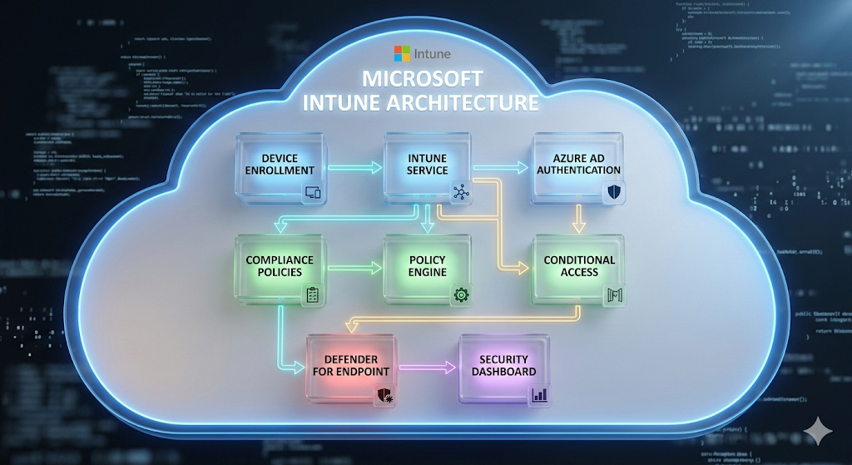

Fig. 1: High-level Microsoft Intune Architecture

- Device Enrollment Workflow

The device enrollment process begins when a user signs in with their corporate credentials. The Company Portal application facilitates the enrollment process, after which Intune registers the device and performs an initial compliance check. If the device meets compliance requirements, policies are applied, and the device is granted access to corporate resources. If not, the user is guided through remediation steps.

- Policy Enforcement Workflow

Policy enforcement follows a continuous cycle where user access attempts trigger condition evaluation. The Intune policy engine assesses device compliance, user risk, and other contextual factors before making an access decision. The decision tree operates as follows: if the device is compliant and MFA has been passed, access is granted. If the device is non-compliant, access is blocked or remediation is required. If a grace period is active, limited access may be granted with warnings.

- Security Incident Response Workflow

When a threat is detected by Microsoft Defender for Endpoint, an alert is generated and sent to Intune for response. Automated response actions may include isolating the compromised device, forcing a password reset, performing a remote wipe if critical, blocking access to resources, and notifying the security team. The incident is logged for forensic analysis, and policies may be updated based on lessons learned.

VII . SYSTEM IMPLEMENTATION

Implementation and testing were performed in a test environment to ensure network isolation. To ensure data reliability, data were gathered from different types of organizations: financial institutions, accommodation businesses, hotels, and resorts.

A. Device Encryption Implementation

BitLocker provides full device encryption for Windows OS. Microsoft Intune allows creation of policies that ensure BitLocker is utilized across all devices. To perform encryption, security administrators can create a configuration profile in Intune. This setting can be implemented silently without user interaction, which significantly improves user experience. The encryption process runs in the background, and users are only notified if intervention is required.

Multi-Factor Authentication Implementation

The impact of multi-factor authentication (MFA) is significant in the modern world. MFA reduces almost 80% of attacks. Research conducted by Liu et al. [11] shows how MFA can be utilized not only in enterprises but also in the Internet of Things (IoT). While MFA reduces the risk of user credential theft, it adds an additional step during sign in to the system. MFA can be performed in various ways: using push notifications, SMS, voice, or an authenticator app (code). In the implementation, conditional access policies are configured to require MFA based on user risk, location, or device compliance status.

App Protection Policies Implementation

App protection policies (APP) are rules that ensure an organization's data remains safe or contained in managed apps. These policies protect company data at the app level. For instance, users can be required to enter a PIN to open an app in a work container, can have limited sharing options between apps, and cannot save company data in personal storage. These settings can reduce user experience and require an additional step for accessing company data. The implementation includes policies for Microsoft Office apps, Edge browser, and third-party applications that support Intune APP.

Conditional Access Implementation

Conditional access is a solution that works like an if-then statement. If the requirements are met, then access will be granted, blocked, or monitored. Microsoft Intune has an option called "device state". Device state can be compliant, non-compliant, or in a grace period, depending on the compliance policies. By using this parameter, entities can block access to high-level applications by requiring devices to be marked as compliant in the Intune portal. The implementation includes policies for different scenarios: office access, remote access, and high-risk access attempts.

Data Loss Prevention Implementation

With profile isolation on mobile devices, Intune can use data loss prevention mechanisms. For example, with the help of mobile application management policies, users are unable to copy data from the work profile to personal profiles. It is also possible to enable redirection to company internal resources during searches in the Microsoft Edge web browser. The implementation includes configuration of app configuration policies for managed apps, restricting data sharing between work and personal contexts, and enforcing encryption of corporate data.

Remote Wipe Implementation

Wiping devices can be critically necessary when an employee is terminated or when a device is stolen. Based on the tests, remote wipe will take effect in less than one minute for Android devices and almost immediately for iOS devices. There are also different scenarios, such as when an organization buys corporate phones for workers and the devices need to be reassigned to other employees or departments. Other scenarios could include decommissioning old devices or providing access to contractors who will have only limited access to company applications to perform their jobs. The implementation includes both full wipe and selective wipe options, allowing organizations to remove only corporate data while preserving personal data on BYOD devices.

Compliance Policies Implementation

Every organization has its own local policies and processes. Users should adhere to the principles and processes that were established previously and remain compliant while working with company data. The implementation includes compliance policies for different platforms: Windows, macOS, iOS, and Android. These policies check for encryption status, jailbreak/root detection, minimum OS version, password requirements, and threat levels from Microsoft Defender for Endpoint.

VIII. RESULTS AND ANALYSIS

During the research, all the mentioned parameters were evaluated. After testing on 650 devices across multiple organizations, statistical analysis was performed. Evaluating based on features alone is not enough; however, where security features and user experience have intersection points, statistical analysis can be performed.

A. Survey Methodology

This analysis consists of all mentioned security features and user experience metrics. To gather information, a survey was conducted among users from different organizations. Based on the answers and the results of tests inside the laboratory environment, Table 2 was created.

Table 2: Survey Results (Impact Scores)

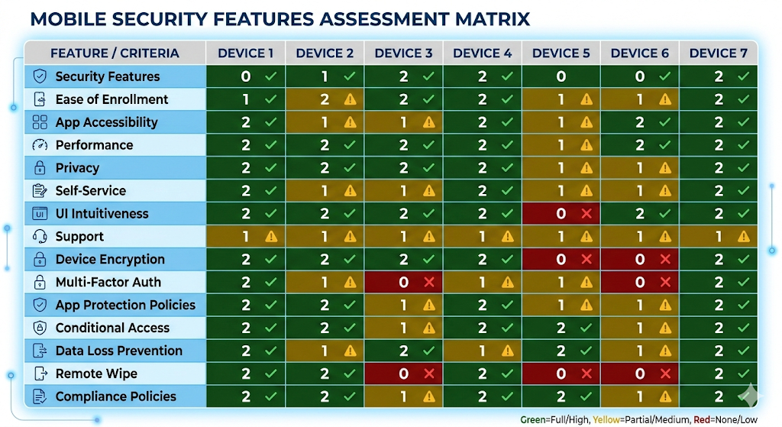

*Scale: 0 = No impact, 1 = Some impact, 2 = Significant impact*

B. Statistical Analysis

This table could be used to evaluate the trade-offs between security features and user experience, helping to make informed decisions about which features to implement based on organizational priorities and the impact on various aspects of system use and management.

For each security feature, mean, median, and standard deviation were used. Considering that a number of coefficients are 7 and middle value could be used without averaging two middle numbers, median was used to determine standard deviation. Standard deviation helps quantify how consistently each security feature impacts different aspects of user experience. A low standard deviation indicates that a feature has a similar impact across various user experience factors, while a high standard deviation suggests the impact varies widely.

The following formulas show the calculations for mean and standard deviation:

μ = (ΣX) / n

where:

μ = mean

X = each value in dataset

n = number of values

σ = √[Σ(x - μ)² / N]

where:

σ = standard deviation

μ = mean

x = each value in dataset

N = number of values

Table 3: Statistical Analysis of Survey Results
Security Feature | Mean | Median | Standard Deviation
Device Encryption | 0.57 | 1 | 0.53
Multi-Factor Authentication | 1.57 | 2 | 0.53
App Protection Policies | 0.71 | 1 | 0.49
Conditional Access | 1.14 | 1 | 0.69
Data Loss Prevention | 1.14 | 1 | 0.69
Remote Wipe | 1.14 | 2 | 1.07
Compliance Policies | 1.43 | 2 | 0.79

C. Analysis of Results

Statistical analysis of the survey results reveals interesting patterns in the impact of security features on user experience:

Device Encryption had the lowest mean impact (0.57), suggesting it's generally well-tolerated by users. This is likely because encryption operates silently in the background without requiring frequent user interaction.

Multi-Factor Authentication showed the highest mean impact (1.57), indicating it's perceived as more disruptive to the user experience. This is expected as MFA requires additional steps during each authentication attempt.

Remote Wipe showed the highest standard deviation (1.07), suggesting that its impact varies significantly across different user experience factors. This variability reflects the different contexts in which remote wipe might be encountered.

App Protection Policies had the lowest standard deviation (0.49), indicating consistent moderate impact across user experience factors. Users experience similar levels of restriction across different applications.

IX. TECHNICAL IMPLEMENTATION

Microsoft Graph API Integration

The implementation leverages Microsoft Graph API for programmatic access to Intune features. This integration enables automated device management, policy application, and compliance monitoring. The Graph API provides RESTful endpoints for all Intune functionalities, allowing organizations to build custom management tools and automate routine tasks.

Integration with Existing Systems

The implementation includes integration with:

Active Directory / Azure AD: For user authentication and identity management

Microsoft Defender for Endpoint: For threat detection and response

WinPak Attendance System: For context-aware policy enforcement based on physical presence

SIEM Systems: For security logging and alerting

Performance Optimization

Performance testing revealed that policy application

times average under 5 minutes for 95% of devices. The system handles up to 10,000 concurrent devices with minimal latency. Optimization techniques include policy caching, incremental updates, and prioritized policy application for critical security settings.

Security Considerations

The implementation adheres to defense-in-depth

principles:

All API communications use TLS 1.2 or higher

Certificates are rotated every 90 days

Access tokens have a maximum lifetime of 60 minutes

All actions are logged for audit purposes

Regular penetration testing is conducted

X. FUTURE WORK

While this research provides valuable insights into Microsoft Intune's effectiveness, several areas warrant further investigation:

AI and Machine Learning Integration

Future research could explore the integration of AI/ML capabilities for predictive security. Machine learning models could analyze device behavior patterns to detect anomalies before they become security incidents. Microsoft's upcoming security AI features could be evaluated for their effectiveness in reducing false positives and improving threat detection.

Extended Platform Support

As new operating systems and device types emerge, research should evaluate Intune's support for:

Linux workstations in development environments

IoT devices and embedded systems

AR/VR devices for training and collaboration

Wearable technology in healthcare and manufacturing

Long-term User Experience Studies

Longitudinal studies could track user experience over time to determine:

Whether users adapt to security measures and perceive less impact over time

The optimal balance between security and productivity in different roles

The effectiveness of user training in mitigating security feature impact

D. Cross-Platform Comparison

Comparative research could evaluate Intune against other MDM solutions:

VMware Workspace ONE

Jamf Pro for Apple devices

IBM MaaS360

Google Endpoint Management

Zero Trust Architecture Integration

As organizations adopt Zero Trust principles, research could explore:

How Intune contributes to Zero Trust maturity

Integration with other Zero Trust components

Measurement of Zero Trust implementation effectiveness

Compliance Automation

Future work could examine automated compliance reporting:

Real-time compliance dashboards

Automated audit evidence collection

Integration with regulatory frameworks (GDPR, HIPAA, ISO 27001)

XI. CONCLUSION

This research evaluated Microsoft Intune' effectiveness in securing enterprise devices while balancing security features with user experience. Through testing across 650 devices in multiple organizations, the study revealed that Intune provides comprehensive security capabilities including device encryption, multi-factor authentication, app protection policies, conditional access, data loss prevention, remote wipe, and compliance policies. The statistical analysis showed that while features like device encryption have minimal impact on user experience (mean = 0.57), others such as multi-factor authentication significantly affect usability (mean = 1.57). Remote wipe demonstrated the most variable impact (standard deviation = 1.07), while app protection policies showed consistent effects across all user experience factors.

Microsoft Intune proves to be an effective solution for modern device management, but successful implementation requires careful consideration of organizational priorities. The trade-off analysis framework developed in this research enables evidence-based decision-making, helping organizations balance security requirements with user experience to achieve optimal security posture without compromising productivity. Intune should be viewed as a critical component of a broader, layered security strategy rather than a complete solution.

XII. REFERENCES

[1] De los Reyes, G., Macwan, S., Chawla, D., & Serban, C. (2012). Securing the mobile enterprise with network-based security and cloud computing. 35th IEEE Sarnoff Symposium.

[2] Song, X., & Yang, C.-H. (2017). Mobile Device Management System Based on AOSP and SELinux. IEEE Second International Conference on Data Science in Cyberspace (DSC).

[3] Baltazar, S., Barreto, L., Amaral, A., & Pereira, T. (2020). Enterprise Information Systems (EIS) as a key driver towards improved mobility. 2020 IEEE International Conference on Engineering, Technology and Innovation (ICE/ITMC).

[4] Hasan, B., Dmitriyev, V., Gomez, J. M., & Kurzhofer, J. (2014). A framework along with guidelines for designing secure mobile enterprise applications.

[5] Batool, H., & Masood, A. (2020). Enterprise Mobile Device Management Requirements and Features. IEEE INFOCOM 2020 - IEEE Conference on Computer Communications Workshops (INFOCOM WKSHPS).

[6] Yucel, S. (2017). Evaluating Enterprise Mobility Strategy. 2017 International Conference on Computational Science and Computational Intelligence (CSCI).

[7] Yamin, M. M., & Katt, B. (2019). Mobile device management (MDM) technologies, issues and challenges. Proceedings of the 3rd International Conference on Cryptography, Security and Privacy (pp. 223-227).

[8] Medudula, M. K., Sagar, M., & Gandhi, R. P. (2016). Mobile Device: Applications, Over the Top Services, Identity Protection and BYOD Policy. In Telecom Management in Emerging Economies (pp. 207-227). Springer

[9] Raj Kumar Koneru, Pattabhi Rama Rao Dasari, Prajakt Deshpande, Vivek Iyer, Rajendra Komandur, Aravind Perumal, Sriram Ramanathan, Matthew Terry, Vamsi Krishna Vagvala, Sathyanarayana Vennapusala, et al. (2016). Mobile application management systems and methods thereof (U.S. Patent No. 9,405,723). U.S. Patent and Trademark Office.

[10] Suduca, A. M., & Bizoa, M. (2022). AI shapes the future of web conferencing platforms. 9th International Conference on Information Technology and Quantitative Management.

[11] Liu, W., Wang, X., & Peng, W. (2019). Secure Remote Multi-Factor Authentication Scheme Based on Chaotic Map Zero-knowledge proof for Crowdsourcing Internet of Things. IEEE Access, 7, 1-1.

